**Christ the Redeemer**

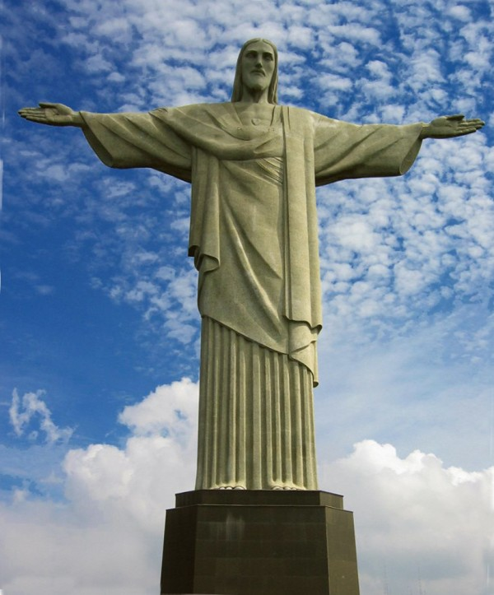

The monument “O Cristo Retendor” is interpreted in English as “Christ the Redeemer.” The one hundred and twenty foot statue stands on top of Corcovado Hill in the city of Rio de Janeiro, representing the religious nature of Brazil. Built between 1922 and 1931, O Cristo Retendor is made of Soapstone and reinforced concrete. The monument was designed by Heitor Da Silva Costa, and sculpted by Paul Landowski. O Cristo Retendor became known as one of the Seven Wonders of the World on July 7, 2008.